LESS COMMAND

team1

1. View a text file with less
As showed in the syntax, you can use the less command to view a file in the following fashion:
less [option]<filename>

2. Exit from less
If you are not used to of less command, you might struggle to find how to exit less. Trust me it’s not at all complicated. Simply press ‘q’ at any given point to exit from less.

3. Moving around in less
The output of less is divided into sort of pages. You’ll see only the text that fills up to your terminal screen.
Up arrow – Move one line up
Down arrow – Move one line down
Space or PgDn – Move one page down
b or PgUp – Move one page up
g – Move to the beginning of the file
G – Move to the end of the file
ng – Move to the nth line

4. Display line numbers with less
If you want to see the line numbers in the less command output, you can use the option N in the following manner:

less -N <filename>

5. Finding text in less
If you have a large text file, it’s better to search for a specific piece of text rather than reading it line by line in order to find it manually.

To find a word or phrase or even a regex pattern, press / and type whatever you want to find.

/pattern

6.View multiple files with less command

To open multiple files with less, simply input the file names one by one:

less <filename1> <filename2> <filename3>
:n to move next file
:p to move to previous file

7. less -X file name
save the file name on screen when file exits

8.less -S file name
long line can be seen by side wrapping.

9.less--version to know the version of less

10. less -m file name

show more detailed prompt including file position.
-N option:
This option shows the file with line number.
Example:
less -N cars.txt
It gives the output as follows
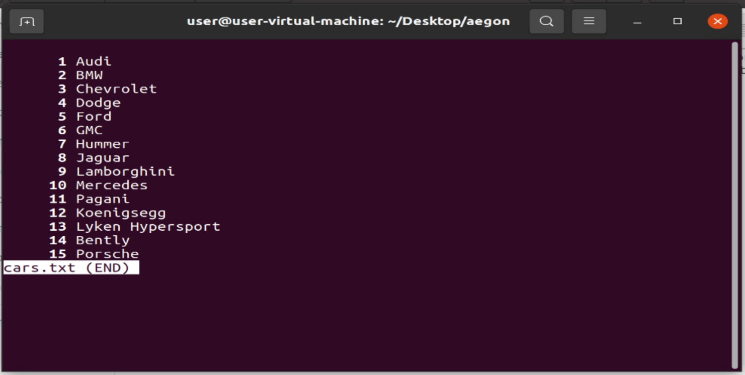
-F option:
This option causes less to exit if entire file can be displayed on first screen.
Example:
less -F cars.txt
It gives the output as follows.
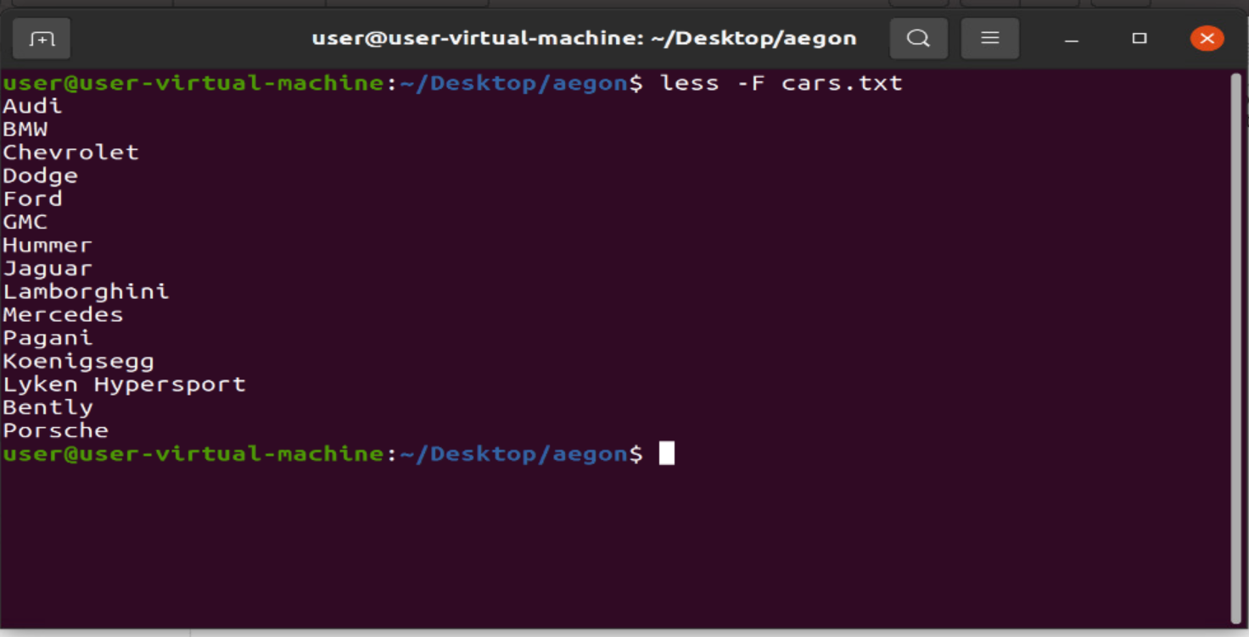
The above cars.txt file contents is displayed on firsts screen so, the less exit the file automatically.

-G option:
It hides all highlighting strings found by search command. To highlight the strings do -G again.

Example:
In less editor press ‘-’ and then ’G’, It will hides all highlighting strings found by search command as image follows.

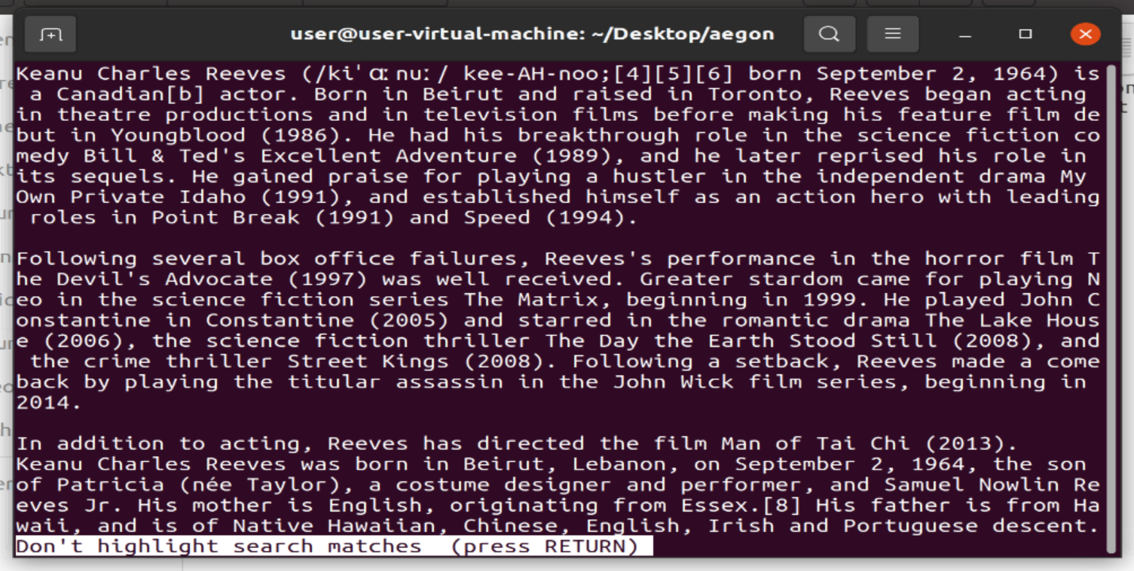
-N and -F
We can use combination of -F option along with -N option to avoid opening of file.
Example:
less -N -F cars.txt
It gives the output as follows
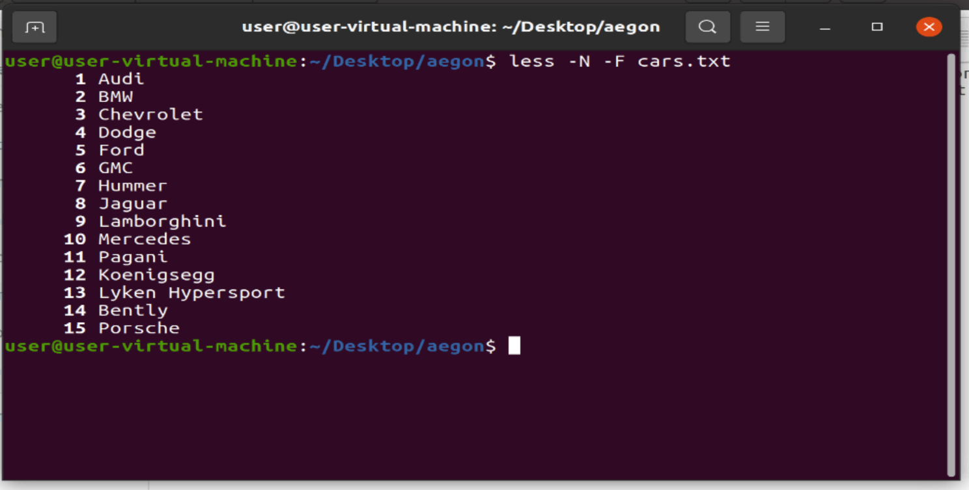

-s option:
causes consecutive blank lines to be squeezed into single blank line.

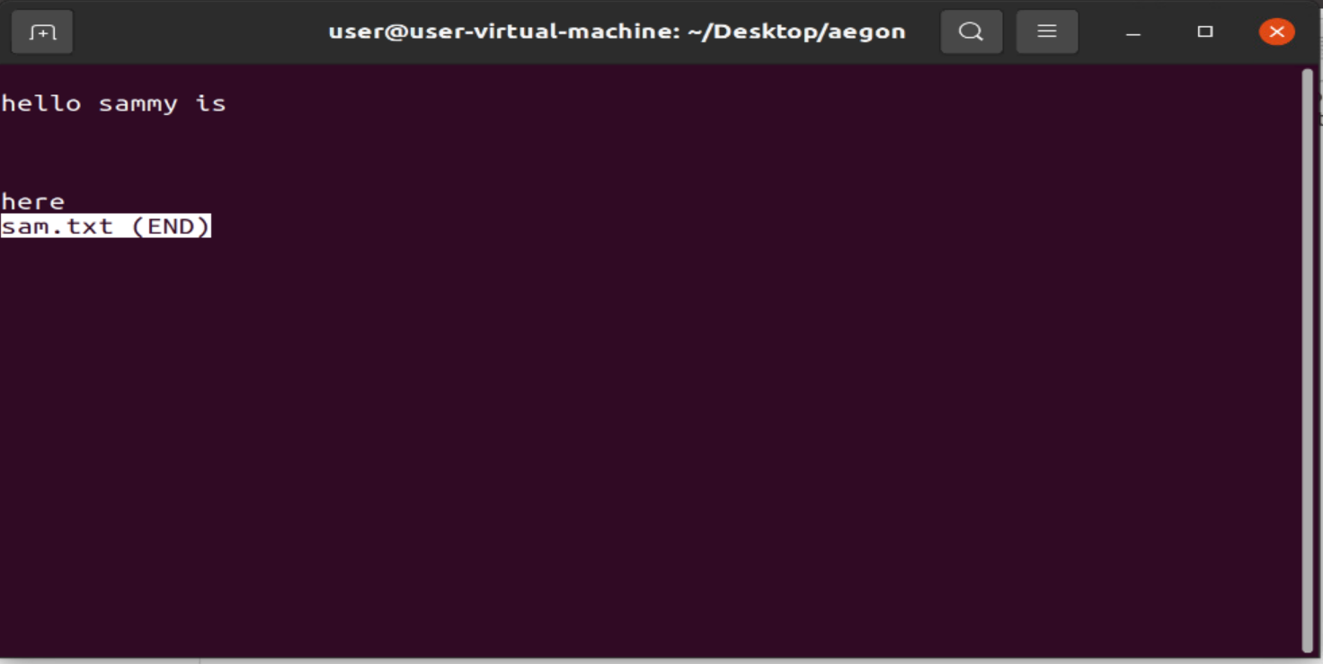
Example:
I created a file with consecutive blank lines as follows.

In the less editor press ‘-’ and ‘s’ then the consecutive blank lines are squeezed as follows.
